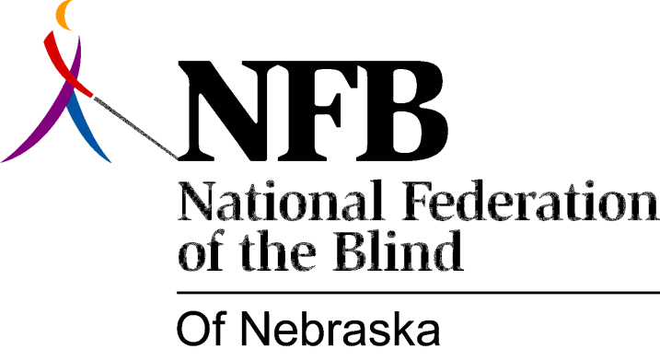

Resolution 1978 – 04
Re: Establishment of a Full-Time Position for the Coordination of Educational Services to Visually Impaired Children

WHEREAS, Government is designed to be the servant of the people, not their master, and

WHEREAS, this ideal relationship calls for clearly delineated lines of responsibility which provide adequate access to the appropriate arm of the delivery system and

WHEREAS, in particular, the service delivery system designed to implement in Nebraska the Education of All Handicapped Childrens' Act, is hopelessly confused and therefore thwarts legitimate efforts of parents to secure for their children an education in the least restrictive environment, and

WHEREAS, there has been a further weakening of the State's capability to fulfill the requirements of the Act through an administrative arrangement which delegates primary responsibility in practical effect, if not in law, to the Nebraska School for the Visually Handicapped; thereby creating an apparent conflict of interest and

WHEREAS, there is complete unanimity among consumer organizations of the blind in support of clearly separate and identifiable responsibilities for the provision of equal educational opportunities for blind children in the public schools, now, therefore,

BE IT RESOLVED, by the National Federation of the Blind of Nebraska, in convention assembled this 17th day of June, 1978, in the city of Omaha, Nebraska, that the State of Nebraska establish a full-time position for the coordination of educational services to visually impaired children in the public schools, and

BE IT FURTHER RESOLVED, that this position be independent of the Nebraska School for the Visually Handicapped and

BE IT FURTHER RESOLVED, that copies of this resolution be sent to Governor Exon, to the Commissioner of Education and to other appropriate persons as designated by the President of the National Federation of the Blind of Nebraska.

Passed unanimously, June, 1978.

