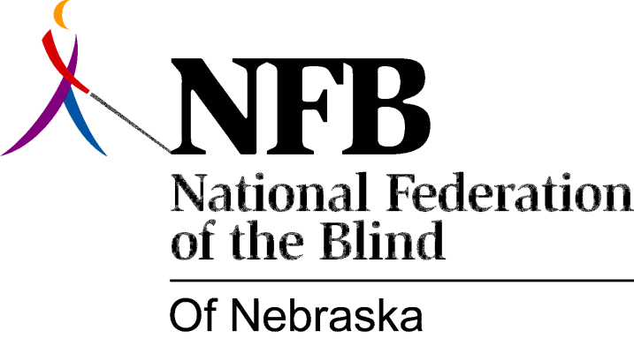

Resolution 1978 – 07
Re: Concerning the Establishment of Insurance Regulations Prohibiting Discrimination Against the Blind

WHEREAS, the blind have been discriminated against in the purchase of insurance solely on the basis of blindness and

WHEREAS, no actuarial evidence exists to support treatment of the blind as a class in the purchase of insurance and

WHEREAS, no actuarial evidence exists to prove that blind people are a greater risk and

WHEREAS, the burden of proof rests with the insurance carrier and not with those seeking insurance and

WHEREAS, a task force of the National Association of Insurance Commissioners recently had passed a model regulation prohibiting discrimination against the blind in insurance now, therefore,

BE IT RESOLVED, by the National Federation of the Blind of Nebraska, in convention assembled this 17th day of June, 1978, in the city of Omaha, Nebraska, that this organization urge the Nebraska Department of Insurance to promulgate regulations which prohibit insurance practices which discriminate against the blind and

BE IT FURTHER RESOLVED, that this organization encourage the Nebraska Department of Insurance to work with the National Federation of the Blind of Nebraska in promulgating these regulations and

BE IT FURTHER RESOLVED, that the Secretary of this organization be instructed to forward copies of this resolution to the Nebraska Insurance Commissioner, the Governor, and appropriate public officials as designated by the President.

Passed unanimously, June, 1978.

