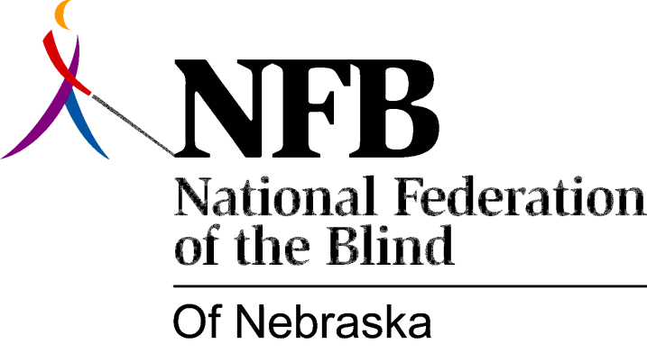

Resolution 1981 – 04
RE: The Library for the Blind and Physically Handicapped

WHEREAS, the current status as well as potential changes in library services to the blind must be discussed with blind consumers;

WHEREAS, the NFB-N is the largest organized group of consumers in the state; and,

WHEREAS, the director of the Nebraska Library for the Blind and Physically Handicapped declined an invitation to appear at the NFB-N state convention due to advanced sick leave;

WHEREAS, numerous attempts to secure another representative from NLBPH through the director of the Nebraska State Library Commission also failed; and,

WHEREAS, this lack of responsiveness on the part of NLBPH to our request is consistent with overall lack of responsiveness to blind consumers regarding library services; now, therefore,

BE IT RESOLVED, by the NFB of Nebraska assembled in convention this first day of November, 1981 in the city of Omaha, that this organization condemn and deplore irresponsible behavior of NLBPH toward blind consumers; and,

BE IT FURTHER RESOLVED, that this organization demand responsiveness and interaction with the library regarding its current status and possible changes to determine their impact on library services to the blind; and,

BE IT FURTHER RESOLVED, that copies of this resolution be sent to the director of NLBPH, the director of the Nebraska State Library Commission and other appropriate officials as designated by the president.

