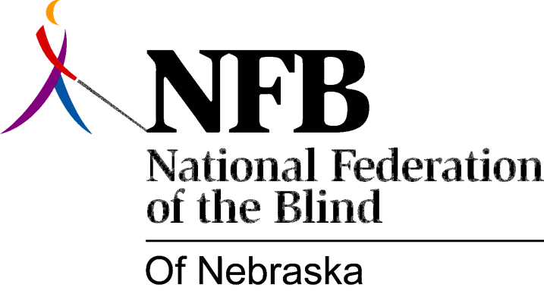

Resolution 1982 – 06
RE: Commend Cindy Wanek and the KOLN / KGIN Staff

WHEREAS, education of the public concerning blindness is one of the major purposes of the National Federation of the Blind; and,

WEREAS, the media plays an important role in helping us to educate the public; and,

WEREAS, the ETC. program of October 15, 1982, aired on KOLN / KGTN TV, portrayed the blind in a positive and realistic manner; now, therefore,

BE IT RESOLVED, by the national Federation of the Blind of Nebraska, in convention assembled, this 17th day of October, 1982, in the city of Grand Island, Nebraska, that this organization commend and applaud the excellent portrayal of blindness in the October 15th ETC. program; and,

BE IT FURTHER RESOLVED, that this organization express its’ appreciation directly to Cindy Wanek, Producer and Editor of this segment, and to the KOLN/KGIN staff; and,

BE IT FURTHER RESOLVED, that we continue to pursue similar educational programming.

