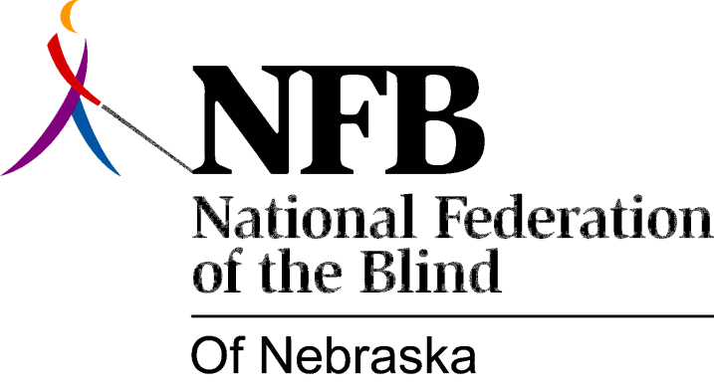

RESOLUTION 1984-02

RE: Maintaining Quality Training at N.S.V.I. Orientation Center

WHEREAS, the Director of Nebraska Services for the Visually Impaired has proposed the implementation of a three-month program for blind college students; and ,

WHEREAS, this program would take place in the orientation center, with participants receiving training along with students concurrently enrolled in the standard orientation program; and,

WHEREAS, the summer program calls for accelerated training in cane travel and vocational development; and,

WHEREAS, the staff time necessary to the provision of such intensive training would reduce the ability of staff people to offer quality training to all students; now, therefore,

BE IT RESOLVED, by the National Federation of the Blind of Nebraska, in convention assembled this 13th day of October, 1984, in the city of North Platte, Nebraska, that we call upon the Director of N.S.V.I. to work with this organization in establishing a means whereby the agency can best meet the needs of blind college students without detriment to the orientation center program.

