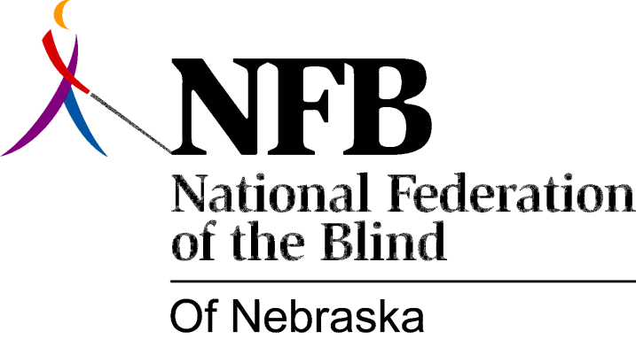

RESOLUTION 1984-07

RE: Public Education

WHEREAS, the National Federation of the Blind has always placed a strong emphasis on our commitment to educate the general public about blindness and the true capacity of blind people; and,

WHEREAS, we appreciate any opportunity to convey our message to the public; and,

WHEREAS, the city of Omaha has enabled the National Federation of the Blind of Nebraska to reach many of its employees through the presentation of workshops to three components of city government, those being: the staff of the city Personnel Office; all city Affirmative Action officials and the Office of Employment Resources; now, therefore,

BE IT RESOLVED, by the National Federation of the Blind of Nebraska, in convention assembled this 14th day of October, 1984, in the city of North Platte, Nebraska, that we commend they city of Omaha for affording the N.F.B.N. the opportunity to educate its employees with regard to blindness; and,

BE IT FURTHER RESOLVED, that the Secretary of this organization be instructed to send copies of this resolution to the three afore-mentioned departments, the Mayor of the city of Omaha and the Omaha City Council, as an expression of our appreciation and to encourage continued progress in this educational effort.

