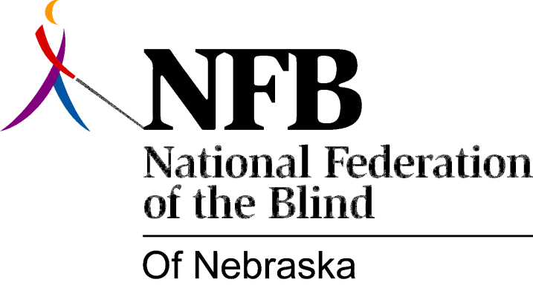

RESOLUTION 1984-101

RE: Consolidation of the Nebraska Schools for the Deaf and Blind

WHEREAS, the National Federation of the Blind is committed to promoting security, equality and opportunity for all blind persons; and,

WHEREAS, a quality education is essential for all blind children in order that they may participate fully and equally in society; and,

WHEREAS, the special educational needs of blind children, such as Braille, large print and cane travel, are totally distinct from the needs of deaf children; and,

WHEREAS, the Nebraska School for the Visually Handicapped (NSVH) is currently able to provide a quality education to the blind students in attendance because of its singular emphasis on blindness; and,

WHEREAS, the consolidation of educational programs and services for the blind and the deaf would necessarily reduce the effectiveness of service delivery to all children involved; and,

WHEREAS, the recent decision to employ a superintendent to oversee both educational institutions could lead to such a detrimental consolidation; now, therefore,

BE IT RESOLVED, by the Board of Directors of the National Federation of the Blind of Nebraska in conference assembled this 27th day of June, 1984, that this organization be on record as opposing any consolidation of educational programs for blind children with educational programs for deaf children; and,

BE IT FURTHER RESOLVED, that the Secretary of this organization be instructed to send copies of this Resolution to: the members of the Nebraska State Board of Education; Dr. Joe Lutjeharms, Commissioner of Education; Dr. Jason Andrew, Associate Commissioner of Education and Mr. Jerry Regler, Head Administrator, Nebraska School for the Visually Handicapped.

