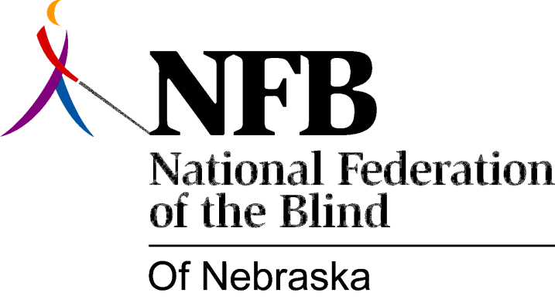

RESOLUTION 1985-02

RE: The Nebraska Department of Insurance Investigating Insurance Discrimination

WHEREAS, the Nebraska Department of Insurance has promulgated rules to amend Chapter 35, Sections 44-101.01 and 44-1533 R.R.S., 1943, to read that “acts or practices which constitute unfair discrimination between individuals of the same class: refusing to insure, or refusing to continue to insure, or limiting the amount, extent or kind of coverage available to an individual, or charging an individual a different rate for the same coverage solely because of blindness or partial blindness” are prohibited: and,

WHEREAS, the Nebraska Department of Insurance has adopted these rules and regulations to correct and rectify specific inadequacies which have been recognized by the National Association of Insurance Commissioners through the initiative of the National Federation of the Blind; and,

WHEREAS, the Nebraska Department of Insurance has had specific requests to investigate violations of these regulations adopted in June of 1978 and amended in April of 1985; and,

WHEREAS, the Nebraska Department of Insurance has not been consistent in investigating cases of reported discrimination with respect to its own regulations; and,

WHEREAS, eye diseases and conditions (such as glaucoma, retinitis pigmentosa, cataracts, and optic atrophy) do not constitute a direct relationship to other disabling conditions and, therefore, do not justify adjustments or modifications in coverages given the absence of actuarial evidence: Now, therefore,

BE IT RESOLVED, by the National Federation of the Blind of Nebraska, in Convention assembled this 12 day of October, 1985, in the city of Grand Island, Nebraska, that this organization request the Nebraska Department of Insurance to investigate all complaints of violations of the above mentioned regulations in a consistent and thorough manner and that all parties be properly and adequately questioned to assure that all facts have been ascertained and all complaints or questions be responded to in compliance with the regulations prior to decisions and conclusions; and,

BE IT FURTER RESOLVED, that companies suspected of discriminatory practices by appropriately and immediately reprimanded and / or given notice of proper and necessary corrective action to be taken; and,

BE IT FURTHER RESOLVED, that the President of this organization (or designated persons) submit this Resolution to and seek rectification of this problem with the Commissioner of the Nebraska Department of Insurance; and,

BE IT FURTHER RESOLVED, that this Resolution be published in the public newspapers towards notifying blind persons and agents of our concern.

