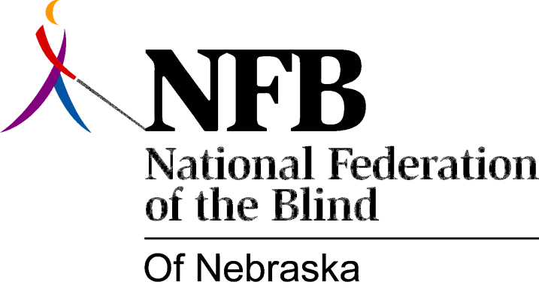

RESOLUTION 1985-03

RE: Quality Education for Blind Children in Nebraska

WHEREAS, current trends indicate that an increasing number of blind children are receiving their education in a public school setting; and,

WHEREAS, there presently exists no formalized system for evaluating or insuring the effectiveness of the academic and skill training provided to blind children attending public schools; and,

WHEREAS, this organization believes it is essential for all blind children to receive an education which is equal in quality to that which is provided to their sighted peers and which includes thorough training in the alternative skills of blindness: Now, therefore,

BE IT RESOLVED, by the National Federation of the Blind of Nebraska, in Convention assembled this 13th day of October, 1985, in the city of Grand Island, Nebraska, that this organization, in partnership with the Department of Education, establish a formal mechanism to evaluate the quality of education currently being provided to blind children in Nebraska’s public schools; and,

BE IT FURTHER RESOLVED, that this body be responsible for insuring that quality education and skill training is provided on an on-going basis to all blind youngsters in public schools in Nebraska; and,

BE IT FUTHER RESOLVED, that this body inform parents of blind children as to their right to select the educational setting (residential, mainstream, or other) which best meets the needs of their blind child.

