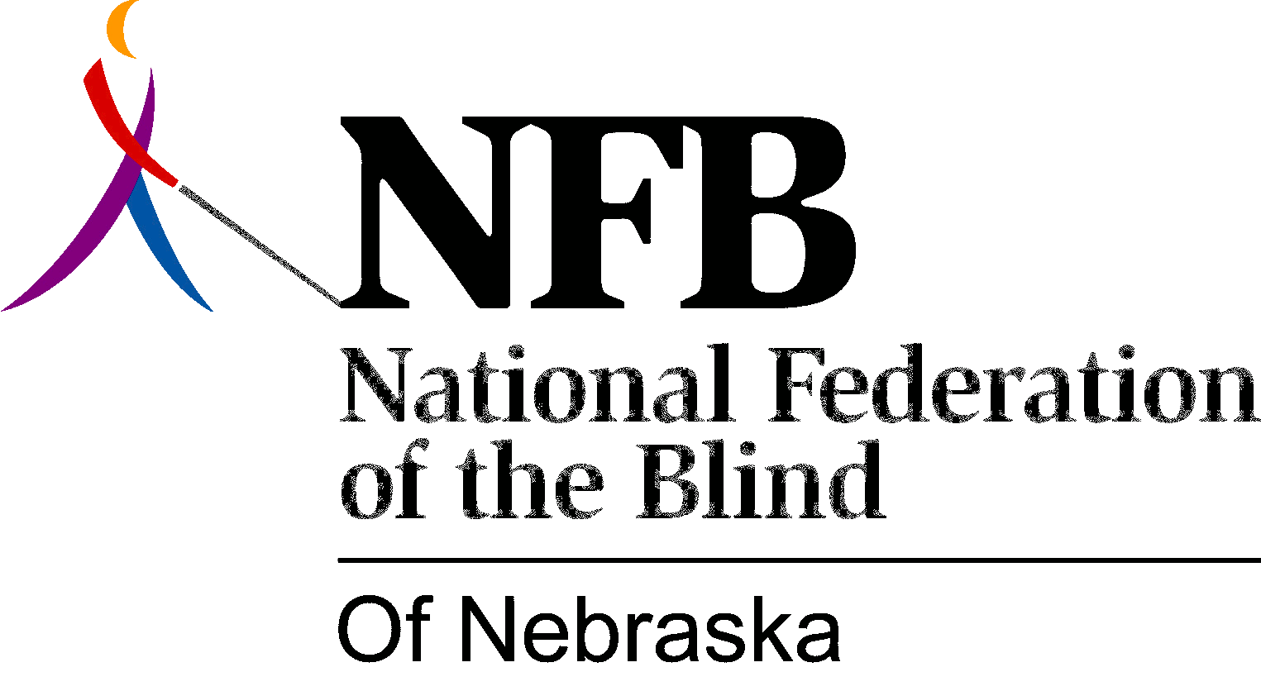

RESOLUTION 1989-01

RE: Radio Station KESY

Whereas, a major goal of the National Federation of the Blind is to change public attitudes about blindness; and,

Whereas, one method used to effect attitudes is the production and distribution of public service announcements (PSAs); and,

Whereas, by October, 1988, Jim Milrow, Public Service Director for KESY Radio, was contacted about the possible airing of the national PSAs; and,

Whereas, Mr. Milroy indicated that his station produced its own PSAs, using people from local organizations, allowing those people to record the PSA in KESY's studio; and,

Whereas, since October, 1988, one special event and three generic PSAs have been produced and aired on behalf of the National Federation of the Blind of Nebraska, amounting to nearly $5,000 in donated services by KESY; and,

Whereas, a strong working relationship has developed between Jerry Eckery, Public Relations Coordinator for the NFBN, and Jim Milroy, KESY Public Service Director; and,

Whereas, Mr. Milroy enthusiastically accepted an invitation to address the convention of the NFBN and attend its banquet; now, therefore

Be It Resolved, by the National Federation of the Blind of Nebraska in Convention assembled, this seventh day of October, 1989, in the city of York, Nebraska, that this organization commend Jim Milroy and KESY Radio; and,

Be It Further Resolved that copies of this resolution be presented to Jim Milroy, KESY Public Service Director, and Dana Webb, KESY General Director.

Adopted Unanimously.

