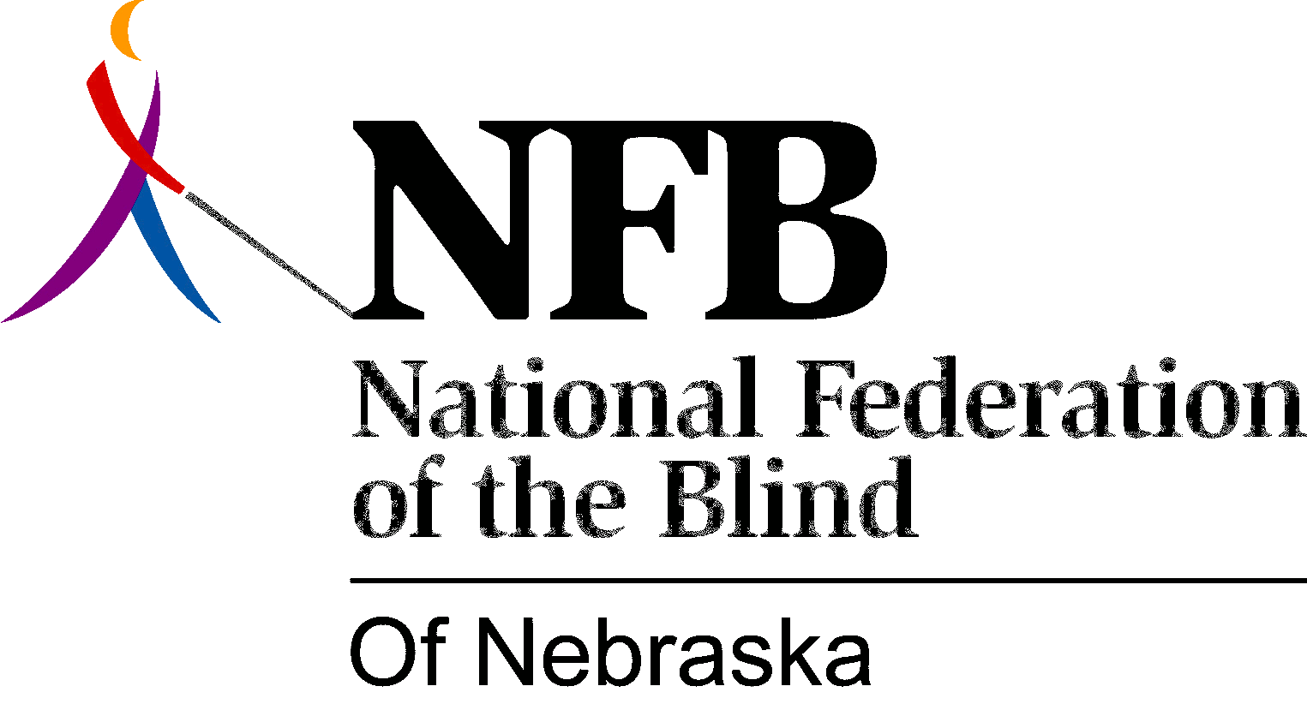

Resolution 1990-02

RE: Advisory Committee to Nebraska Services for the Visually Impaired

WHEREAS, the National Federation of the Blind of Nebraska believes that the blind have the same range of skills, talents, and potential for excellence as sighted persons; and

WHEREAS, blind persons are employed as competent travel instructors throughout the country with excellent results and without danger to their students; and

WHEREAS, a blind person who is learning the skills of travel with a long white cane gains additional self-confidence from an instructor who is competently using the skills that are being taught; and

WHEREAS, Nebraska Services for the Visually Impaired (NSVI) has a long history of hiring competent blind travel instructors; and

WHEREAS, the policy of hiring blind travel instructors in Nebraska has been used as a model for developing other programs for travel instruction, both nationally and internationally; and

WHEREAS, at its re-scheduled meeting on August 11, 1990, which the Federation representative was unable to attend, the Advisory Committee voted by the narrowest of margins abandonment of the policy of independent instruction by blind employees by recommending that blind instructors be required to have sighted assistance when they teach; and

WHEREAS, there is no evidence to show that blind travel instructors have caused any danger or injury to a student or that sighted supervision is necessary or that any injury that may have occurred could have been attributed to the sight or lack of sight of the instructor; and

WHEREAS, any fear felt by a blind travel student is actually fear of blindness itself, not fear of the instructor's blindness; and

WHEREAS, the only way to overcome this fear of blindness is to learn the skills of blindness, not to avoid the issue; and

WHEREAS, the expense of providing sighted assistants for blind instructors would be prohibitive and unnecessary; and

WHEREAS, the attitude that sighted assistance is necessary for safe travel instruction by the blind is demeaning and insulting to the blind; now, therefore,

BE IT RESOLVED by the National Federation of the Blind of Nebraska in convention assembled this 28th day of October, 1990 in the City of Kearney, Nebraska, that this organization oppose the mandatory use of sighted assistants for blind travel instructors; and

BE IT FURTHER RESOLVED, that this organization encourage NSVI to continue to hire instructors based on competence and not on visual acuity; and

BE IT FURTHER RESOLVED, that this organization urge the advisory committee to reverse its position on this matter.

adopted unanimously.

