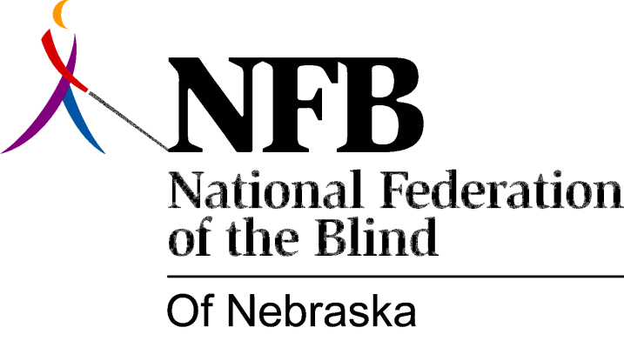

RESOLUTION 1991-02

RE: Commendation of ABC for the Positive Image of Blindness it portrays in “MacGyver”

WHEREAS, the American Broadcasting Company (ABC) has aired the popular series “MacGyver” for several years; and

WHEREAS, the producers of this series have insisted that the character portrayed by Dana Elcar be retained, even though the actor is blind; and

WHEREAS, the attitudes and ideas expressed through this character have been extremely positive and have clearly demonstrated that blind persons are normal, competent and can compete on equal terms with sighted persons; these views are shared and supported by the National Federation of the Blind (NFB), the largest organization of the blind in the nation; now, therefore,

BE IT RESOLVED THAT the National Federation of the Blind of Nebraska in convention assembled this 6th day of October, 1991, commend and applaud the outstanding achievements of the producers and stars of this program for their positive beliefs in the abilities of the blind and for ensuring that Dana Elcar, as a blind person, would be viewed as a competent and normal first class citizen.

