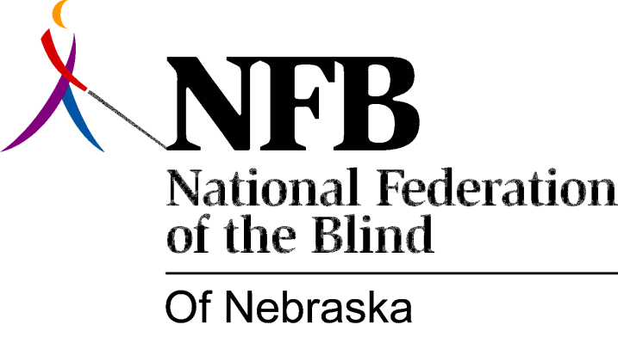

Resolution 1995-04

RE: Television Crawlers

Whereas, the average blind person watches television as often as does the average sighted person; and

Whereas, television stations frequently broadcast significant information, including but not limited to: sports scores; community calendars; weather information; school closings and public service announcements in print only; and

Whereas, this practice denies blind people equal access to this important information and violates the spirit of the ADA; Now, therefore,

Be it resolved, by the National Federation of the Blind of Nebraska, in convention assembled this 22nd day of October, 1995, in the city of Grand Island, Nebraska, that we call upon all television stations in Nebraska to correct this practice by reading printed information as it is broadcast, thereby ensuring equal access to all blind persons.

