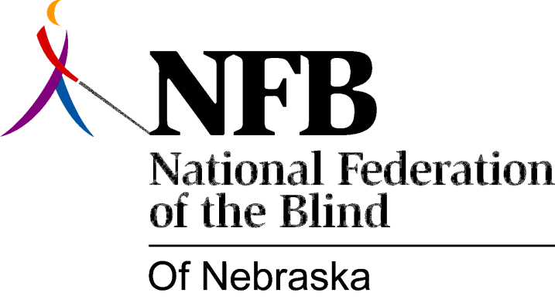

Resolution 1996-03

RE: Condemning the State of Nebraska for its Plans to Combine SVI with the General Rehab Agency

Whereas, The Nebraska Partnership for Health and Human Services significantly affects rehabilitation services to Blind Nebraskans by absorbing the Department of Public Institutions (the umbrella agency under which services for the Visually Impaired is now located) into the newly created Department of Health and Human Services; and

Whereas, The partnership plan contemplates requiring rehabilitation professionals serving blind clients, to spent a portion of their time working in other social service programs such as Aid for Families With Dependent Children (AFDC) and the food stamp program; and

Whereas, this requirement violates the Federal Rehabilitation Act; and

Whereas, a violation of the Federal Rehabilitation Act could result in a withdrawal of funding by the Rehabilitation Services Administration which currently provides 78.7 percent of Nebraska's rehabilitation dollars; and

Whereas, In January of 1996, Governor Ben Nelson, Lieutenant Governor Kim Robak and Partnership Chairperson Don Leuenberger each personally assured members of the National Federation of the Blind of Nebraska that we would be actively involved in the planning and design phase of the Partnership, through inclusion in work groups established by the Partnership; and

Whereas, the membership of the National Federation of the Blind of Nebraska includes rehabilitation professionals, administrators and attorneys, possessing expertise in vocational rehabilitation, administration, federal law and regulation; and

Whereas, Governor Ben Nelson, Lieutenant Governor Kim Robak and Partnership Chairperson Don Leuenberger breached their promises to the members of the National Federation of the Blind of Nebraska and failed to act in good faith when they refused to allow meaningful input into the planning process; and

Whereas, the receipt of notice of public forums, Partnership newsletters and updates does not constitute meaningful involvement in the process; now, therefore,

Be It Resolved, by the National Federation of the Blind, in Convention assembled, this 12th day of October, 1996 in the City of Columbus Nebraska, that this organization condemn and deplore the actions of Governor Ben Nelson, Lieutenant Governor Kim Robak and Partnership Chairperson Don Leuenberger in blatant disregard of federal law and of the legitimate concerns expressed by the National Federation of the Blind; and

Be It Further Resolved, that we call upon Governor Ben Nelson, Lieutenant Governor Kim Robak and Partnership Chairperson Don Leuenberger to work cooperatively with the National Federation of the Blind in order to preserve Nebraska's 78.7 percent federal funding and a separate service delivery system for rehabilitation services to blind Nebraskans, as required by federal law; and

Be It Further Resolved, that this resolution be widely distributed to the media across Nebraska.

