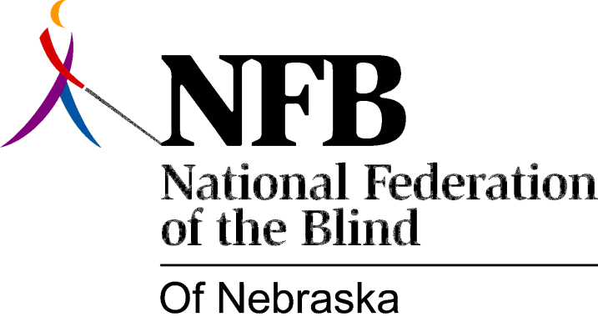

RESOLUTION 1999-01

RE: DHHSN-Focus Computer System

WHEREAS, it is the mission of the National Federation of the Blind of Nebraska to promote equality, opportunity and security for the blind; and

WHEREAS, the Americans with Disabilities Act (ADA) is a aw enacted in 1990 to protect the civil rights of the disabled; and

WHEREAS, under the ADA, employers are required to provide reasonable accommodations to blind persons; and

WHEREAS, the Nebraska Department of Health and Human Services (DHHS) is a major employer in the state of Nebraska; and

WHEREAS, in 1991, DHHS began a process which ultimately led to the procurement of a new comprehensive computer system, known as N-Focus, at the cost of $80 million (eighty million dollars); and

WHEREAS, between that time and now, an additional $57.9 million (fifty-seven million nine hundred thousand dollars) has been spent on this system; and

WHEREAS, from the outset, DHHS was told that this system would not be accessible to blind persons; and

WHEREAS, in spite of that, DHHS, when designing and acquiring the N-Focus system, failed either to consult with any organization of blind persons or even with its own blindness-related sub-unit, Nebraska Rehabilitation Services for the Visually Impaired (NRSVI); and

WHEREAS, most jobs with DHHS require the use of this system; and

WHEREAS, the Department’s offer of a full-time reader as accommodation is a band aid rather than a solution to the problem of access to the computer system; and

WHEREAS, this practice neither encourages DHHS to hire blind persons nor meets the requirements of the ADA; Now, therefore,

BE IT RESOLVED by the National Federation of the Blind of Nebraska, in Convention assembled this tenth day of October, 1999, in the city of Scottsbluff, Nebraska, that this organization call upon the Nebraska Department of Health and Human Services (DHHS) to do whatever is necessary to make the N-Focus system equally accessible to blind and sighted employees; and

BE IT FURTHER RESOLVED that this organization urge DHHS to work with us to complete this project on or before June 30, 2000.

