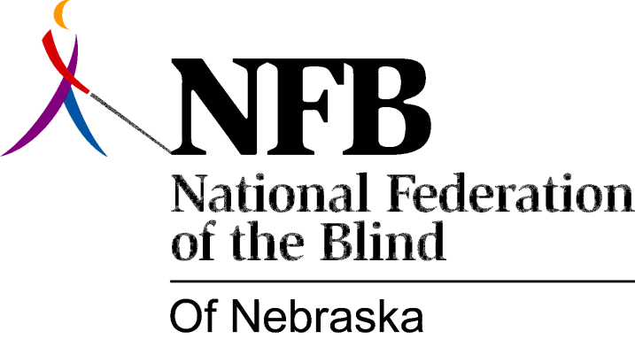

Resolution 2000-01
RE: Change in Tax Code for Blind Vendors
WHEREAS, the Nebraska Business Enterprise Program (BEP) has been providing business and career opportunities for blind vendors for many years; and
WHEREAS, while the national average yearly income for blind vendors is $32,500, the average yearly income for a blind vendor in Nebraska is $16,850; and
WHEREAS, much of the funding for the vending program comes from the vendors themselves, through set aside money and Federal matching funds; and
WHEREAS, this funding mechanism allows for little or no program expansion; and
WHEREAS, available vending sites in Nebraska cannot be procured because of lack of sufficient funding; and
WHEREAS, although Regulation 1-087 of Nebraska Sales and Use Tax Code provides that grocery stores do not pay sales tax on food items, blind vendors do pay a 6.5% sales tax on those same items; and
WHEREAS, of the money currently paid to the State Revenue Department in sales tax, if the entire amount could be earmarked and transferred to the Nebraska Commission for the Blind and Visually Impaired (NCBVI), it could capture Federal funds at the ratio of 21.3% to 78.7%; and
WHEREAS, the amount available as match, some one hundred twenty thousand dollars, would bring in about four hundred eighty thousand dollars; and
WHEREAS, This would save the State of Nebraska money currently paid in benefits to unemployed and underemployed blind people without the need for appropriating additional funds; and
WHEREAS, this would augment existing funds; and
WHEREAS, this amount would allow for increased services and better opportunities for blind Nebraskans served by the Commission; now, therefore,
BE IT RESOLVED by the National Federation of the Blind of Nebraska in Convention assembled this eighth day of October, 2000, in the city of Omaha, Nebraska, that this organization support this plan which would enable more blind Nebraskans to earn a living wage without jeopardizing already-existing funding mechanisms of either the Business Enterprise Program (BEP) or the Nebraska Commission for the Blind and Visually Impaired (NCBVI) as a whole; and
BE IT FURTHER RESOLVED that this organization work with the blind vendors, the NCBVI Board of Commissioners, NCBVI staff, the Legislature and the Governor to bring about this change in Nebraska tax code.

