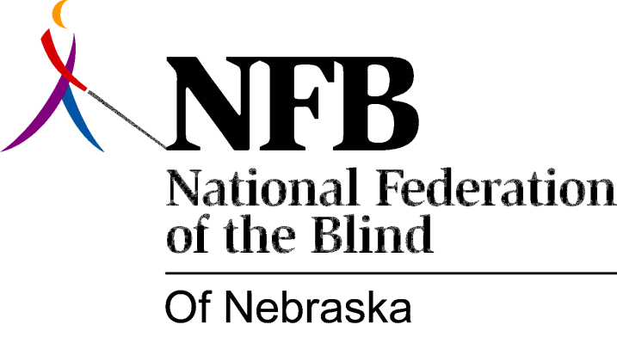

Resolution 2011 – 02
RE: Regarding Fair Wages for Nebraska Workers with Disabilities

WHEREAS, the Fair Labor Standards Act (FLSA) was passed in 1938 to provide workforce protections to American employees by establishing a federal minimum wage prohibiting employers from exploiting workers through the payment of wages below this specified minimum; and

WHEREAS, Section 14(c) of the Fair Labor Standards Act permits the secretary of labor to grant special wage certificates allowing specified employers to pay workers with disabilities at rates that are lower than the federal minimum wage, eliminating those workforce protections granted to every other American citizen; and

WHEREAS, paying workers with disabilities subminimum wages stems from the public misperception that people with disabilities cannot be productive employees; moreover, this exploitive standard for employment is patronizingly considered a compassionate opportunity for people with disabilities to receive the "tangible and intangible benefits of work"; and

WHEREAS, when provided effective rehabilitation services, training, and support, employees with disabilities (even those with the most significant disabilities) can be as productive as nondisabled workers, obtaining jobs paying the federal minimum wage or higher; and

WHEREAS, though some employers possessing special wage certificates claim to provide rehabilitation and training to their disabled workers to prepare them for competitive employment, the fact that such employers can pay their workers less than the federal minimum wage gives them an incentive to exploit the cheap labor provided by disabled workers rather than to prepare those workers for integrated employment in the mainstream economy; and

WHEREAS, there are thirty facilities that possess a special "subminimum" wage certificate in the state of Nebraska, which not only allows them to exploit the labor of people with disabilities through the payment of wages less than the federal minimum wage, but also, in so doing, to deny these same individuals the opportunity to receive the training and support to become competitively employed; and

WHEREAS, the only way to discontinue this wage discrimination against workers with disabilities is to repeal Section 14(c) of the FLSA and to revoke every special wage certificate granted under that provision: Now, therefore,

BE IT RESOLVED, by the National Federation of the Blind of Nebraska in Convention assembled this sixteenth day of October, 2011, in the city of Lincoln, Nebraska, that this organization call upon every entity throughout Nebraska that currently possesses a Special Wage Certificate from the U.S. Department of Labor immediately to surrender its Special Wage Certificate, and to adopt a business model that values each of its employees with disabilities by paying them the federal minimum wage or higher; and

BE IT FURTHER RESOLVED, that this organization urge these entities to join with us in our efforts to encourage the United States Congress to pass the Fair Wages for Workers with Disabilities Act of 2011, which provides an incentive for employers to adopt a business model that pays employees with disabilities the federal minimum wage or higher by phasing out Section 14(c) of the Fair Labor Standards Act and by revoking the certificates issued under that provision so that workers with disabilities are guaranteed the same workforce protections afforded nondisabled employees; and

BE IT FURTHER RESOLVED, that this organization condemn and deplore every entity that continues to exploit people with disabilities through the payment of subminimum wages.

